Service Layer Design
7/12/2026
(Seth Hopkins)
Overview
This service layer will be responsible for authenticating users, managing inventory and meal plans, generating shopping lists, assigning recipes to meal plans, getting recipes from the Spoonacular API, and updating persistent data in a MySQL database using Entity Framework Core.
Here is a diagram showing the interfaces for my respective service layers.
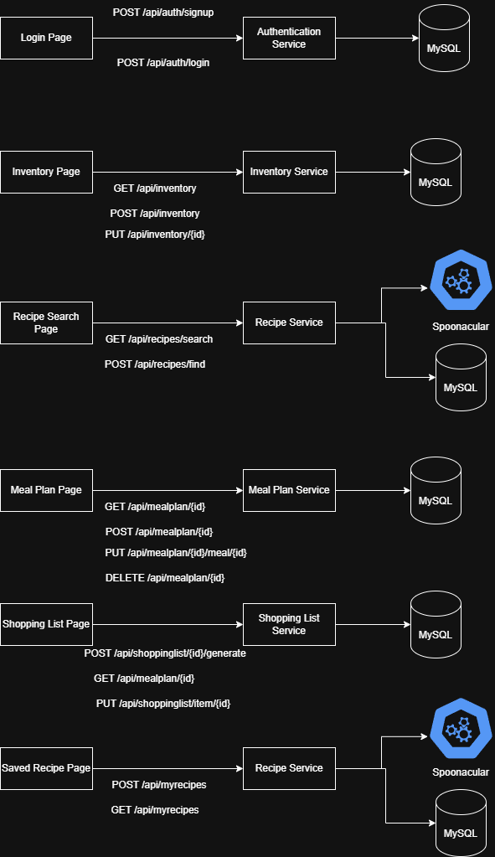
User Authentication
POST /api/auth/signup
Purpose: Add a new user profile to the database.
Request:
{
“email”: “seth@gmail.com”,
“password”: “Password123”,
“first_name”: "Seth”,
“last_name": "Hopkins”,
}
Success Response:
{
“user_id”: 1,
“message”: “Account created!”
}
Error Response:
{
“error”: “Password does not meet minimum requirements.”

}
POST /api/auth/login
Purpose: Authenticates user and returns a JSON web token.
Request:
{
“email”: “seth@gmail.com”,
“password”: “Password123”.
}
Success Response:
{
“token”: “abc123”
}
Error Response:
{
“error”: “Invalid password”
}
Inventory Management
GET /api/inventory
Purpose: Returns the current user’s inventory.
Response:
[
{
“inventory_item_id”: “31”
“quantity”: “1”,
“unit”: “Gal”,
“added”:”2026-07-12”,
“name”: “milk”,
“inventory_id”: “1”,
“api_ingredient_id”: “13”,
},
{
“inventory_item_id”: “21”
“quantity”: “2”,
“unit”: “lb”,
“added”:”2026-07-12”,
“name”: “carrot”,
“inventory_id”: “1”,
“api_ingredient_id”: “12”,
},
{
“inventory_item_id”: “321”
“quantity”: “16”,
“unit”: “oz”,
“added”:”2026-07-12”,
“name”: “tomato paste”,
“inventory_id”: “1”,
“api_ingredient_id”: “123”,
},
]
POST /api/inventory
Purpose: Add new item to inventory.
Request:
{
“quantity”: “5”,
“unit”: “lb”,
“added”:”2026-07-11”,
“name”: “sweet potato”,
“inventory_id”: “1”,
“api_ingredient_id”: “1235”,
},
Response:
{
“message”: “Added”
}
Error Response:
{
“error”: “Quantity cannot be negative.”
}
PUT /api/inventory/1
Purpose: Updates the quantity of an item in the inventory.
Request:
{
“quantity”: 5
}
Response:
{
“message”: “Quantity updated”
}
Error Response:
{
“error”: “Item not found in inventory.”
}
DELETE /api/inventory/321
Purpose: Deletes an ingredient from the user’s inventory.
Response:
{
“message”: “Deleted”
}
Recipes
GET /api/recipes/search?query=pasta
Purpose: Return recipes by title if found within the Spoonacular API
{
"results": [
{
"id": 716429,
"title": "Pasta with Garlic, Scallions, Cauliflower & Breadcrumbs",
"image": "https://img.spoonacular.com/recipes/716429-312x231.jpg",
"imageType": "jpg",
},
{
"id": 715538,
"title": "What to make for dinner tonight?? Bruschetta Style Pork & Pasta",
"image": "https://img.spoonacular.com/recipes/715538-312x231.jpg",
"imageType": "jpg",
}
],
"totalResults": 86
}
POST /api/recipes/find
Purpose: Returns list of recipes that can be made with current inventory with specified ingredients from user.
Request:
{
“name” : [
“Bacon”,
“Eggs”,
]
}
Response:
{
"results": [
{
"id": 445,
"title": "Bacon quiche",
"image": "https://img.spoonacular.com/recipes/445-312x231.jpg",
"imageType": "jpg",
},
{
"id": 446,
"title": "Bacon Omelet",
"image": "https://img.spoonacular.com/recipes/446-312x231.jpg",
"imageType": "jpg",
}
}
Error Response:
{
“error”: “No match found.”
}
Meal Plan
GET /api/mealplan/89
Purpose: Returns the scheduled meals.
Response:
[
{
“meal_id”: “44”,
“meal_date”: “2026-07-12’,
“meal_type”: “breakfast”,
“cooked”: “0”,
“api_recipe_id”: “446”,
“meal_plan_id”: “89”
}
{
“meal_id”: “45”,
“meal_date”: “2026-07-12’,
“meal_type”: “dinner”,
“cooked”: “0”,
“api_recipe_id”: “447”,
“meal_plan_id”: “89”
}
]

]
POST /api/mealplan/89
Purpose: Adds a meal to the selected meal plan.
Request:
{
“queue_id”: “22”,
“api_recipe_id”: “23”,
“time_added”: “2026-07-10 07:58:03”,
“user_id”: “1”
}
Response:
{
“message”: “Meal added”
}
Error Response:
{
“message”: “No meal selected”
}
DELETE /api/mealplan/89
Purpose: Deletes the current meal plan.
Response:
{
“message”: “Meal removed”
}
PUT /api/mealplan/89/meal/45
Purpose: Marks the meal as cooked to update the inventory
Response:
{
“message”: “Inventory updated”
}
Error Response:
{
“error”: “Ingredients already used”
}
Shopping List
POST /api/shoppinglist/1/generate
Purpose: Generates a shopping list based on selected meal plan’s meals and what’s not in the inventory.
Response:
[
{
“shopping_list_id”: “12”,
“quantity”: “16”,
“unit”: “oz”,
“purchased”: “0”,
“name”: “chilli beans”,
“api_ingredient_id”: “34”,
“shopping_list_id”: “1”
},
{
“shopping_list_id”: “13”,
“quantity”: “1”,
“unit”: “lb”,
“purchased”: “0”,
“name”: “ground beef”,
“api_ingredient_id”: “35”,
“shopping_list_id”: “1”
},
]
GET /api/shoppinglist/1
Purpose: Returns the shopping list.
[
{
“shopping_list_id”: “12”,
“quantity”: “16”,
“unit”: “oz”,
“purchased”: “0”,
“name”: “chilli beans”,
“api_ingredient_id”: “34”,
“shopping_list_id”: “1”
},
{
“shopping_list_id”: “13”,
“quantity”: “1”,
“unit”: “lb”,
“purchased”: “0”,
“name”: “ground beef”,
“api_ingredient_id”: “35”,
“shopping_list_id”: “1”
},
]
Error Response:
{
“message”: “Shopping list is empty”
}
PUT /api/shoppinglist/item/13
Purpose: Marks item as purchased in shopping list to add to inventory.
Response:
{
“message”: “Added to inventory”
}
Saved Recipes
POST /api/myrecipes
Purpose: Saves recipe from spoonacular to persistent database.
Request:
{
“api_recipe_id”: “35”,
“user_id”: “1”,
}
Response:
{
“message”: “Recipe saved”
}
GET /api/myrecipes
Purpose: Returns the saved recipes for the user
Response:
{
“saved_recipe_id”: “1”,
“api_recipe_id”: “35”,
“time_added”: “2026-07-12 10:30:20”,
“user_id”: “1”,
}

